# Instructions: Upload a dataset to BigQuery

Using public datasets is a great way to practice working with SQL. Later in the course, we are going to use historical data on avocado prices to perform calculations in BigQuery. Before you go on to the video, here is a step-by-step guide to help you load this data into your own BigQuery console so that you can follow along with the upcoming video.

## Step 1: Download the CSV file from Kaggle

[Avocado prices](https://www.kaggle.com/neuromusic/avocado-prices): The publicly available avocado dataset from Kaggle we are going to use (made available by [Justin Kiggins](https://www.kaggle.com/neuromusic) under an [Open Data Commons](https://opendatacommons.org/licenses/odbl/1-0/) license).

You can download this data onto your own device and then upload it to BigQuery. There are also other public datasets on Kaggle that you can download and use. You can follow these steps to load them into your console and practice on your own!

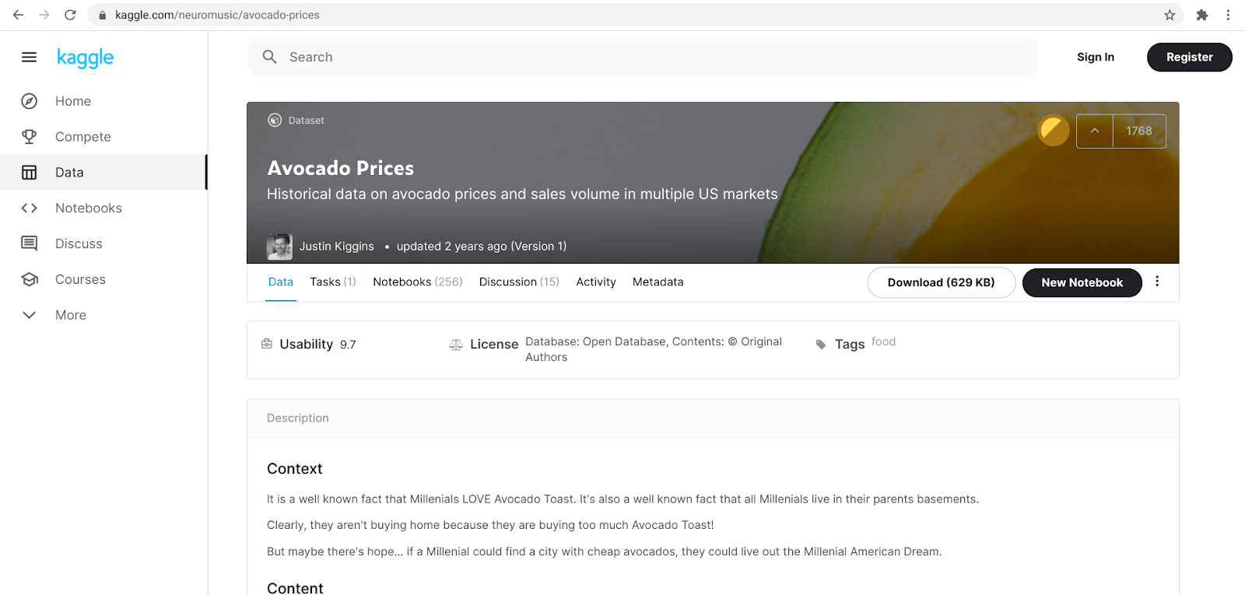

You will find some more information about the avocado dataset, including the context, content, and original source on this page. For now, you can simply download the file.

## Step 2: Open your BigQuery console and create a new dataset

If you haven't already set up a BigQuery account, before you continue, follow the instructions in [Refresher: Using BigQuery](https://www.coursera.org/learn/analyze-data/supplement/J0yQI/refresher-using-bigquery).

[Open BigQuery](https://cloud.google.com/bigquery). After you have downloaded the dataset from Kaggle, you can upload it to your BigQuery console.

In the Explorer on the left side of your console, click the project where you want to add a dataset - note that your project will not be named the same as the one in the example ("oval-flow-286322"). Don't choose "bigquery-public-data" as your project because that's a public project that you can't change.

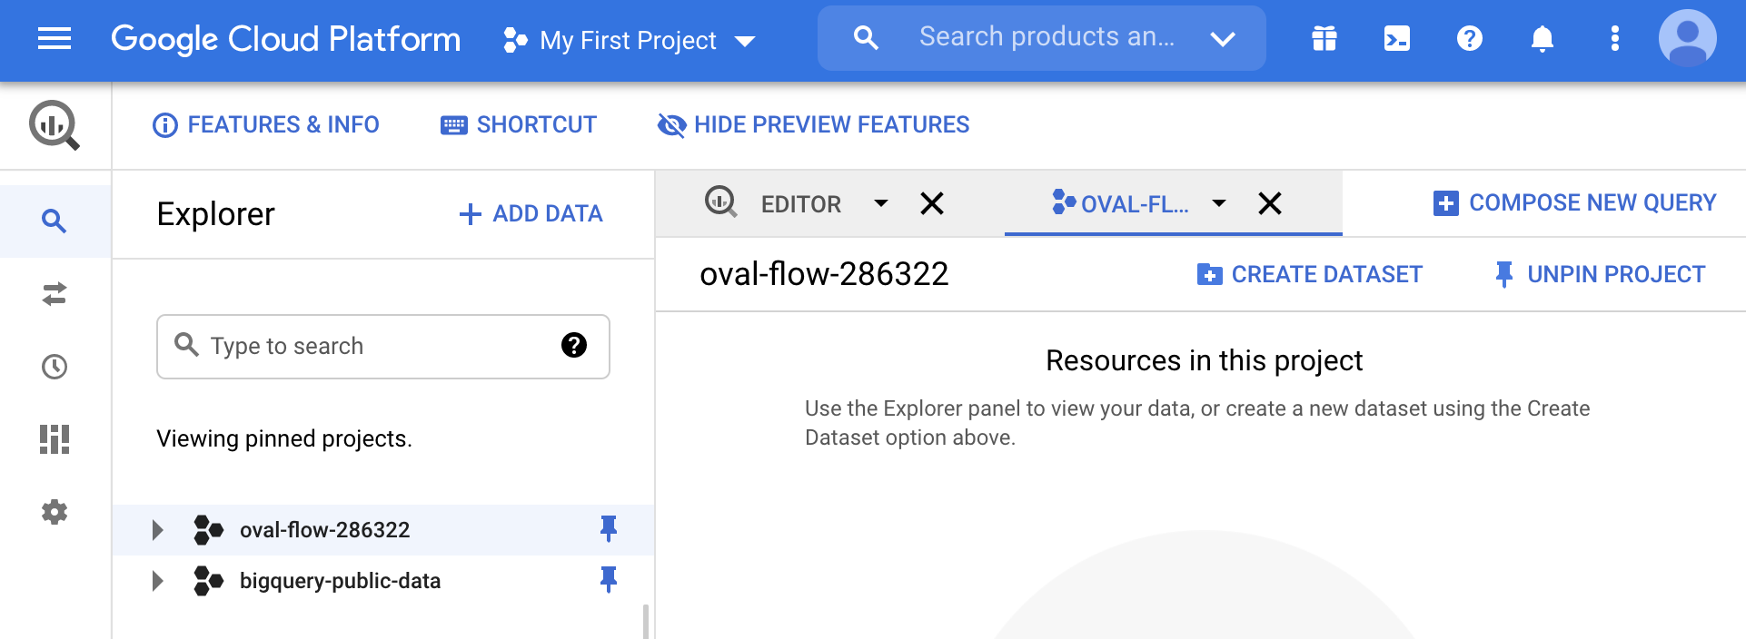

Click the Actions icon (three vertical dots) next to your project and select Create dataset.

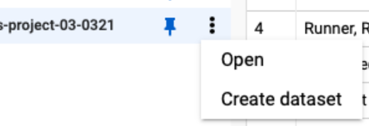

Here, you will name the dataset; in this case, use “avocado_data.” Then, click Create dataset (blue button) at the bottom to create your new dataset. This will add data in the Explorer pane of your console.

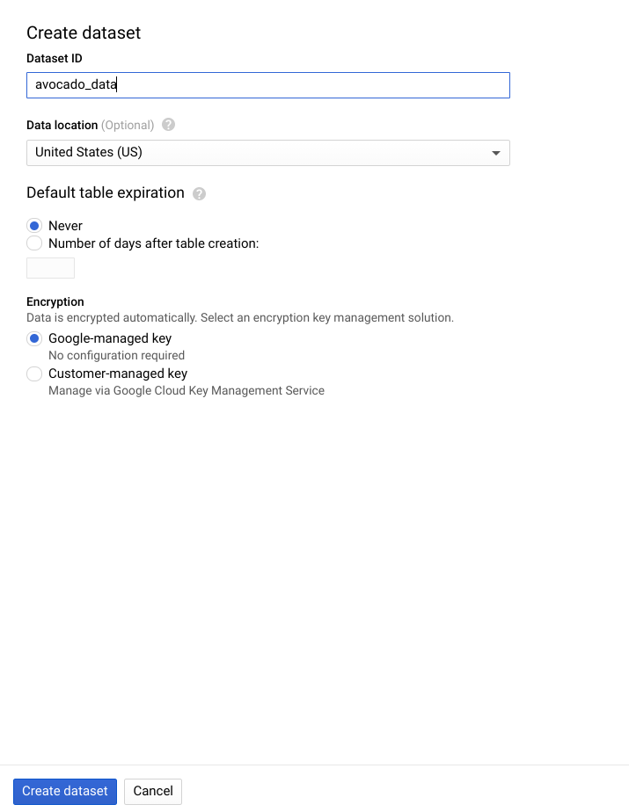

## Step 3: Open the new dataset and create a new table

Navigate to the dataset in your console by clicking to expand your project and selecting the correct dataset listed. In this case, it will be avocado_data.

Screenshot of the Create table menu

Click the Actions icon (three vertical dots) next to your dataset and select Open. Then click the + icon to create a table.

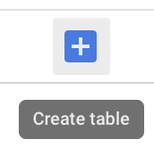

Next, do the following:

* Under Source, for the Create table from selection, select Upload.
* Click Browse to select the CSV file you just downloaded to your computer from Kaggle. The file format should automatically change from Avro to CSV when you select the file.
* For Table Name, enter a name for the table. For Schema, click the Auto detect check box. Then, click Create table (blue button).

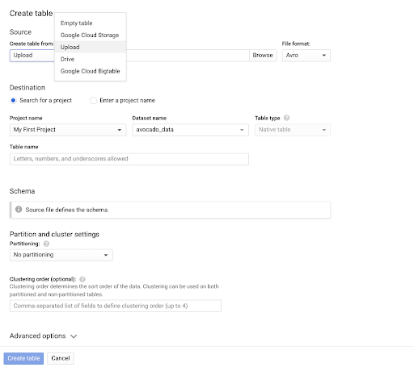

there are options to upload data, name a project, name the table, and more

In the Explorer pane, the avocado data will appear in the table under the dataset you created. Now you are ready to follow along with the video and learn more about performing calculations with queries!

## Further reading

* [Introduction to loading data](https://cloud.google.com/bigquery/docs/loading-data): You will learn more about loading data into BigQuery later, but this step-by-step guide is a useful resource that you can bookmark and save for later so that you have it ready the next time you need to load data into BigQuery.
* [BigQuery: Qwik Start](https://www.qwiklabs.com/focuses/1144?catalog_rank=%7B%22rank%22%3A1%2C%22num_filters%22%3A0%2C%22has_search%22%3Atrue%7D&parent=catalog&search_id=8556556): You will need to be signed into your Qwiklabs account to access this resource. This Qwiklab specifically provides some more hands-on experience with BigQuery, including a guide to getting started, lessons about gaining insights from data in BigQuery, and BigQuery basics for data analysts. This is a great resource to build on your experience working with BigQuery early on.